Developer Manual

# Environment Setup

1. Ensure your operating system is Windows 10, version 2021.1.22 or higher.
2. Download and install Unity version 2020.3.20f1 from <https://unity3d.com/unity/qa/lts-releases>.
   1. Further instructions are available at <https://unity.com/download>
3. Download and install the latest version of git from <https://git-scm.com/downloads>.
4. Clone the project-scoto repository from GitHub using the git command:

$ git clone https://github.com/JamesL-dev/project-scoto.git

1. Launch Unity Hub from the icon on your desktop.
2. Use the “Add” button to navigate to the cloned repository and open the directory at “project-scoto/project-scoto.”
3. Select the now added Unity project to open it.

# Scoto High-level View

## Context Diagram

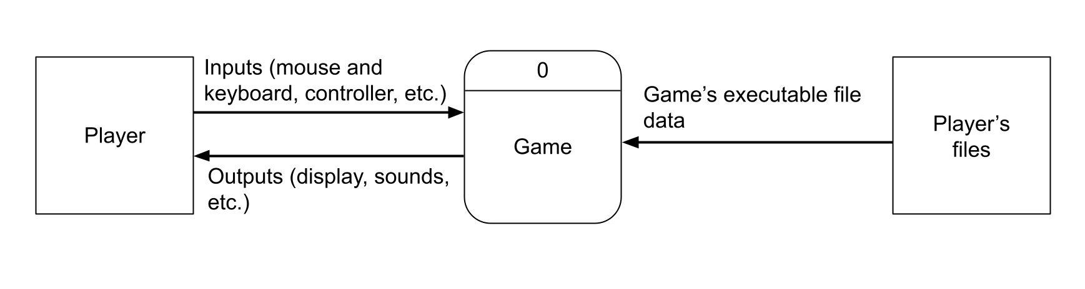

## Class Diagrams

### Overlays

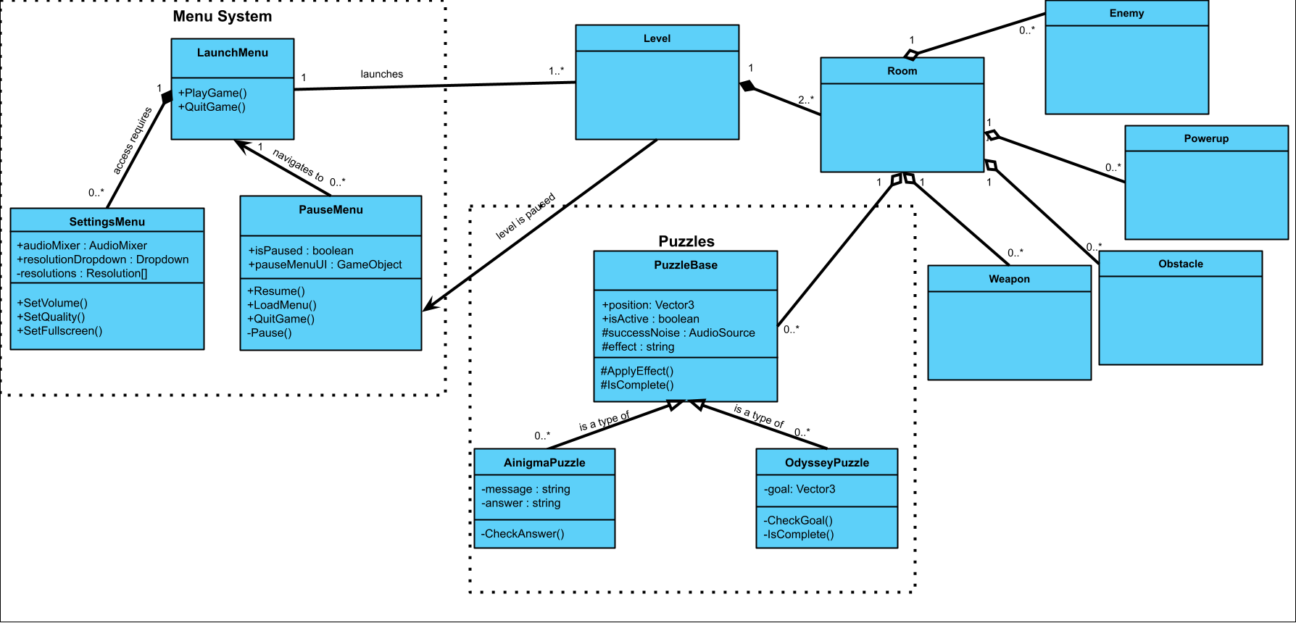

### Level Generation

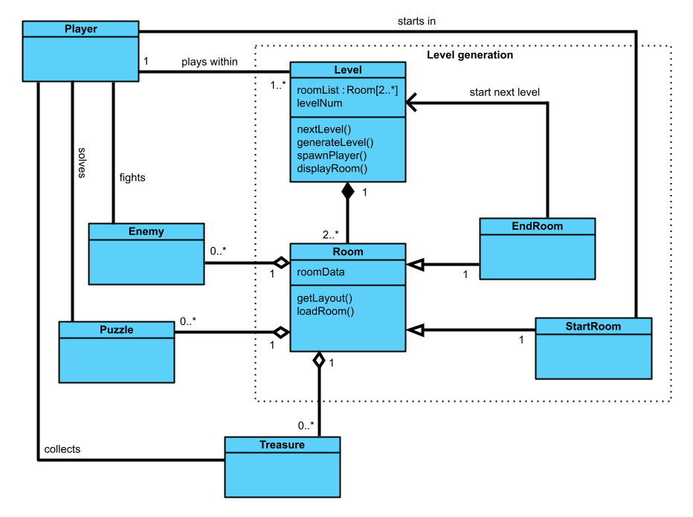

### Weapons

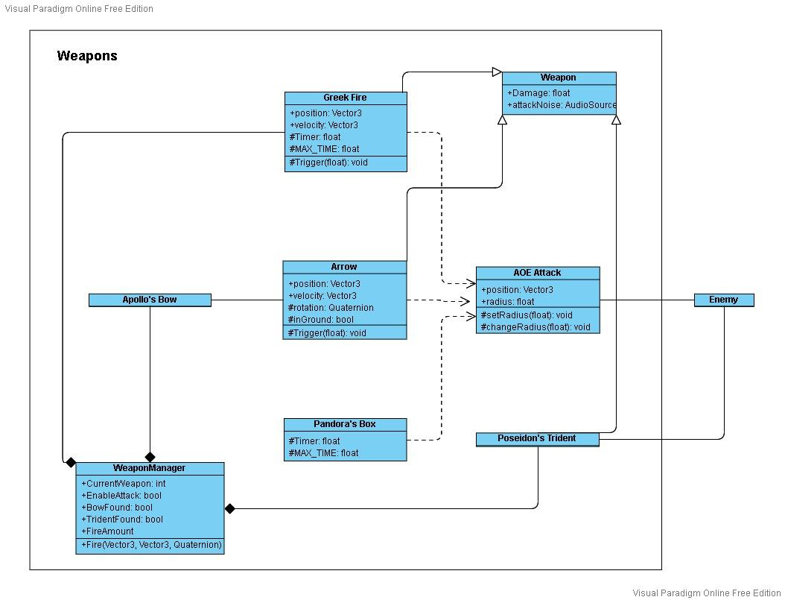

### Enemies & Flashlight

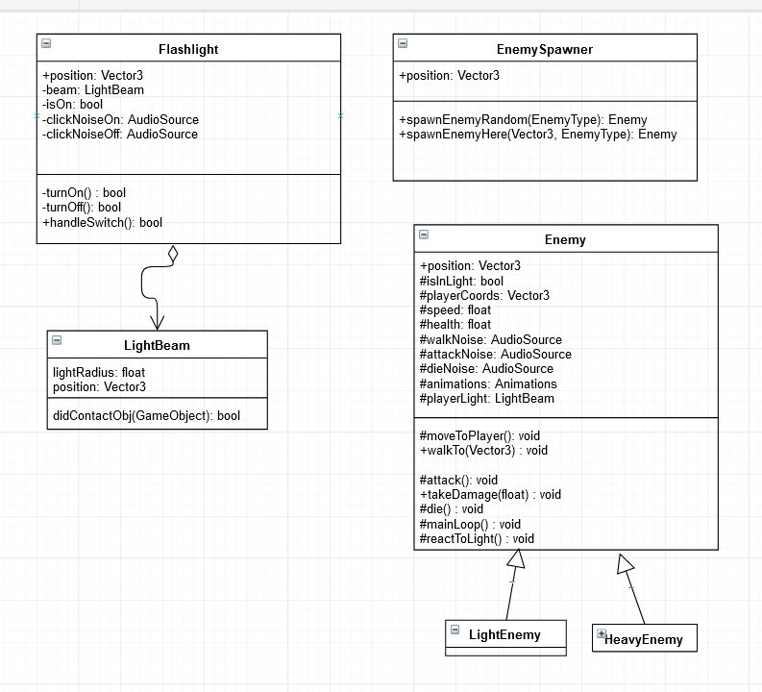

### Pickups & Powerups

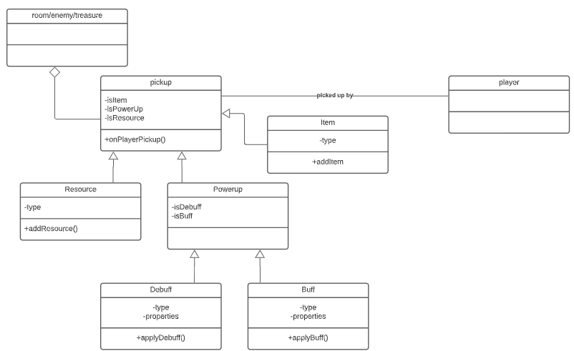

# Technical Topics on Oral Exam

### Documentation

* Follow the documentation guidelines present in the coding standards document
* Ensure comments document all prefabs, C# files, classes, and functions
* Be able to answer the following questions about your documentation:
  + What question are you trying to answer here?
  + Who do you anticipate would be asking that question?

### Code Reuse

* Be able to provide an example of reuse in your code
* Be able to answer the following questions about code reuse:
  + What did you have to do to integrate it with the code you wrote?
  + What are the legal implications if you market your code with the re-used portion?

### Test Plan

* Design and implement a comprehensive test plan
* Provide at least one test case for every non-trivial function
* Be able to answer the following questions about your test plan:
  + What are you testing?
  + Why did you choose these tests?

### Static and Dynamic Binding

* Be able to show a class in your code where there could be either static or dynamic binding.
* Write some mock code showing how you would set the static type and dynamic type of a variable. Choose a dynamically bound method.
  + What method gets called now?
* Change the dynamic type.
  + What method gets called now?
* Pick a statically bound method.
  + Which one would be called in each of the two previous cases?

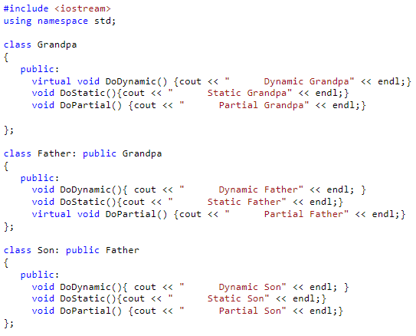

### Software Patterns

* Review the team lead #3 presentation on software patterns if needed (located in the “doc” folder of your GitHub repository or at <https://docs.google.com/presentation/d/1waeLoRyI76LODcnMl0ElI54AugMBw-ERIQgUSHdCivQ/edit#slide=id.gf5d73928cf_0_32>)
* You can find a list of software patterns with class diagrams here: <https://sourcemaking.com/design_patterns>
* Choose and implement at least two patterns

1. Read the problem section of each pattern.
2. Determine if the problem is present in your code.
3. If so, read the example section and confirm it is similar to your situation.
4. Choose the pattern.

* Ensure they are relevant and make sense to use
* Be able to answer the following questions about patterns:
  + Which patterns did you choose?
  + Why did you choose each pattern?
  + Is the use of each pattern justified?
* Choose the pattern you know best. Be able to answer and do the following:
  + Would something else have worked as well or better than this pattern?
  + When would be a bad time to use this pattern?
  + Draw the class diagram for it.

### Creating A Prefab

* Review the team lead #2 presentation on prefabs if needed (located in the “doc” folder of your GitHub repository)
* Prefabs allow you to store a GameObject object with its components and properties as a reusable asset
* New prefab instances can be created from a prefab asset
* Useful for frequently occurring elements like characters or scenery
* Creating a prefab is straightforward:

1. Select **Asset > Create Prefab** in the Unity Editor.
2. Drag an object from the scene onto the “empty” prefab asset that appears.
3. Drag the prefab asset from the project view to scene view to create instances of the prefab.
4. There are now instances of a prefab in your game.

* Helpful resources for more information:
  + <https://docs.unity3d.com/2021.2/Documentation/Manual/Prefabs.html>
  + <https://docs.unity3d.com/2021.2/Documentation/Manual/CreatingPrefabs.html>
  + <https://ouzaniabdraouf.medium.com/how-to-create-prefabs-in-unity-8d2ff87bdad6>